# Linear regression

Linear regression is used to predict a relationship between two variables, one independent, one dependent e.g., the relationship between weight and heigh of individuals.

Linear regression is a great starting point in learning ML. It is supervised learning.

“Regression is a method of modelling a target value based on independent predictors. This method is mostly used for forecasting and finding out cause and effect relationship between variables. Regression techniques mostly differ based on the number of independent variables and the type of relationship between the independent and dependent variables.”[1]

It is useful to make predictions based on known data, for example, if we know what the weather will be like tomorrow, we can predict expected energy usage in homes, or predicting grades based on student behaviour.

It is best when there is a continuous relationship between the independent and dependent variables. If there is no relation or linking between the variables, a linear regression model is not beneficial to the data.

Common real-world examples include examining crop yields against water and fertilisers.

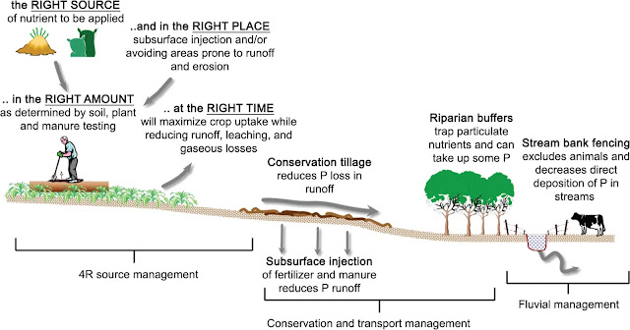[2]

**Correlations**: the interrelation between variables within the data. -1 to +1

**Variance**: the degree of spread of the data

**Standard deviation:** the dispersion of a mean from a dataset by studying the variance’s square root

**Residual** (error term) = the actual value minus the expected value predicted in the linear regression.

**Equation: Simple linear regression**

Y = a + bx

X = the independent variable plotted on the x axis

Y = the dependent variable plotted on the y axis

The intercept = a (Y=0) | the slope of the line is b.

**For machine learning: y= a0+a1x+ ε**

Y= Dependent Variable (Target Variable)  
X= Independent Variable (predictor Variable)  
a0= intercept of the line (Gives an additional degree of freedom)  
a1 = Linear regression coefficient (scale factor to each input value).  
ε = random error

**Note, in real world almost all applications are multivariable linear regression**

**Note: in**

1. https://towardsdatascience.com/introduction-to-machine-learning-algorithms-linear-regression-14c4e325882a
2. https://datasciencepub.blogspot.com/2017/10/real-life-example-for-linear-regression_90.html